|  |  |  |  |  |  |  |  |
| --- | --- | --- | --- | --- | --- | --- | --- |
| **Academic Salaries Dataset** | | | | | | | |
| The data on July month’s salaries of a university’s teaching staffs were collected as part of the administration’s monitoring of gender differences in salary. It comprises salaries of 397 teachers in 2018-2019: | | | | | | | |
| Rank | Discipline | Experience | Years of Service | Sex | Salary | |  |
| Professor | B | 19 | 18 | Male | 139750 | |  |
| Professor | B | 20 | 16 | Male | 173200 | |  |
| Asst. Professor | B | 4 | 3 | Male | 79750 | |  |
| Professor | B | 45 | 39 | Male | 115000 | |  |
| Professor | B | 40 | 41 | Male | 141500 | |  |
| Assoc. Professor | B | 6 | 6 | Male | 97000 | |  |
| Professor | B | 30 | 23 | Male | 175000 | |  |
| Professor | B | 45 | 45 | Male | 147765 | |  |
| Professor | B | 21 | 20 | Male | 119250 | |  |
| Professor | B | 18 | 18 | Female | 129000 | |  |
| Assoc. Professor | B | 12 | 8 | Male | 119800 | |  |
| Asst. Professor | B | 7 | 2 | Male | 79800 | |  |
| Asst. Professor | B | 1 | 1 | Male | 77700 | |  |
| Asst. Professor | B | 2 | 0 | Male | 78000 | |  |
| Professor | B | 20 | 18 | Male | 104800 | |  |
| Professor | B | 12 | 3 | Male | 117150 | |  |
| Professor | B | 19 | 20 | Male | 101000 | |  |
| Professor | A | 38 | 34 | Male | 103450 | |  |
| Professor | A | 37 | 23 | Male | 124750 | |  |
| Professor | A | 39 | 36 | Female | 137000 | |  |
| Professor | A | 31 | 26 | Male | 89565 | |  |
| Professor | A | 36 | 31 | Male | 102580 | |  |
| Professor | A | 34 | 30 | Male | 93904 | |  |
| Professor | A | 24 | 19 | Male | 113068 | |  |
| Assoc. Professor | A | 13 | 8 | Female | 74830 | |  |
| Professor | A | 21 | 8 | Male | 106294 | |  |
| Professor | A | 35 | 23 | Male | 134885 | |  |
| Asst. Professor | B | 5 | 3 | Male | 82379 | |  |
| Asst. Professor | B | 11 | 0 | Male | 77000 | |  |
| Professor | B | 12 | 8 | Male | 118223 | |  |
| Professor | B | 20 | 4 | Male | 132261 | |  |
| Asst. Professor | B | 7 | 2 | Male | 79916 | |  |
| Professor | B | 13 | 9 | Male | 117256 | |  |
| Asst. Professor | B | 4 | 2 | Male | 80225 | |  |
| Asst. Professor | B | 4 | 2 | Female | 80225 | |  |
| Asst. Professor | B | 5 | 0 | Female | 77000 | |  |
| Professor | B | 22 | 21 | Male | 155750 |  |  |
| Asst. Professor | B | 7 | 4 | Male | 86373 |  |  |
| Professor | B | 41 | 31 | Male | 125196 |  |  |
| Assoc. Professor | B | 9 | 9 | Male | 100938 |  |  |
| Professor | B | 23 | 2 | Male | 146500 |  |  |
| Assoc. Professor | B | 23 | 23 | Male | 93418 |  |  |
| Professor | B | 40 | 27 | Male | 101299 |  |  |
| Professor | B | 38 | 38 | Male | 231545 |  |  |
| Professor | B | 19 | 19 | Male | 94384 |  |  |
| Professor | B | 25 | 15 | Male | 114778 |  |  |
| Professor | B | 40 | 28 | Male | 98193 |  |  |
| Professor | B | 23 | 19 | Female | 151768 |  |  |
| Professor | B | 25 | 25 | Female | 140096 |  |  |
| Asst. Professor | B | 1 | 1 | Male | 70768 |  |  |
| Professor | B | 28 | 28 | Male | 126621 |  |  |
| Professor | B | 12 | 11 | Male | 108875 |  |  |
| Asst. Professor | B | 11 | 3 | Female | 74692 |  |  |
| Professor | B | 16 | 9 | Male | 106639 |  |  |
| Assoc. Professor | B | 12 | 11 | Male | 103760 |  |  |
| Assoc. Professor | B | 14 | 5 | Male | 83900 |  |  |
| Professor | B | 23 | 21 | Male | 117704 |  |  |
| Assoc. Professor | B | 9 | 8 | Male | 90215 |  |  |
| Assoc. Professor | B | 10 | 9 | Male | 100135 |  |  |
| Asst. Professor | B | 8 | 3 | Male | 75044 |  |  |
| Assoc. Professor | B | 9 | 8 | Male | 90304 |  |  |
| Asst. Professor | B | 3 | 2 | Male | 75243 |  |  |
| Professor | B | 33 | 31 | Male | 109785 |  |  |
| Assoc. Professor | B | 11 | 11 | Female | 103613 |  |  |
| Asst. Professor | B | 4 | 3 | Male | 68404 |  |  |
| Assoc. Professor | B | 9 | 8 | Male | 100522 |  |  |
| Professor | B | 22 | 12 | Male | 101000 |  |  |
| Professor | B | 35 | 31 | Male | 99418 |  |  |
| Professor | B | 17 | 17 | Female | 111512 |  |  |
| Professor | B | 28 | 36 | Male | 91412 |  |  |
| Professor | B | 17 | 2 | Male | 126320 |  |  |
| Professor | B | 45 | 45 | Male | 146856 |  |  |
| Professor | B | 29 | 19 | Male | 100131 |  |  |
| Professor | B | 35 | 34 | Male | 92391 |  |  |
| Professor | B | 28 | 23 | Male | 113398 |  |  |
| Asst. Professor | B | 8 | 3 | Male | 73266 |  |  |
| Professor | B | 17 | 3 | Male | 150480 |  |  |
| Professor | B | 26 | 19 | Male | 193000 |  |  |
| Asst. Professor | B | 3 | 1 | Male | 86100 |  |  |
| Asst. Professor | B | 6 | 2 | Male | 84240 |  |  |
| Professor | B | 43 | 28 | Male | 150743 |  |  |
| Professor | B | 17 | 16 | Male | 135585 |  |  |
| Professor | B | 22 | 20 | Male | 144640 |  |  |
| Asst. Professor | B | 6 | 2 | Male | 88825 |  |  |
| Professor | B | 17 | 18 | Female | 122960 |  |  |
| Professor | B | 15 | 14 | Male | 132825 |  |  |
| Professor | B | 37 | 37 | Male | 152708 |  |  |
| Asst. Professor | B | 2 | 2 | Male | 88400 |  |  |
| Professor | B | 25 | 25 | Male | 172272 |  |  |
| Assoc. Professor | B | 9 | 7 | Male | 107008 |  |  |
| Asst. Professor | B | 10 | 5 | Female | 97032 |  |  |
| Assoc. Professor | B | 10 | 7 | Male | 105128 |  |  |
| Assoc. Professor | B | 10 | 7 | Male | 105631 |  |  |
| Professor | B | 38 | 38 | Male | 166024 |  |  |
| Professor | B | 21 | 20 | Male | 123683 |  |  |
| Asst. Professor | B | 4 | 0 | Male | 84000 |  |  |
| Assoc. Professor | B | 17 | 12 | Male | 95611 |  |  |
| Professor | B | 13 | 7 | Male | 129676 |  |  |
| Professor | B | 30 | 14 | Male | 102235 |  |  |
| Professor | B | 41 | 26 | Male | 106689 |  |  |
| Professor | B | 42 | 25 | Male | 133217 |  |  |
| Professor | B | 28 | 23 | Male | 126933 |  |  |
| Professor | B | 16 | 5 | Male | 153303 |  |  |
| Professor | B | 20 | 14 | Female | 127512 |  |  |
| Assoc. Professor | A | 18 | 10 | Male | 83850 |  |  |
| Professor | A | 31 | 28 | Male | 113543 |  |  |
| Assoc. Professor | A | 11 | 8 | Male | 82099 |  |  |
| Assoc. Professor | A | 10 | 8 | Male | 82600 |  |  |
| Assoc. Professor | A | 15 | 8 | Male | 81500 |  |  |
| Professor | A | 40 | 31 | Male | 131205 |  |  |
| Professor | A | 20 | 16 | Male | 112429 |  |  |
| Assoc. Professor | A | 19 | 16 | Male | 82100 |  |  |
| Asst. Professor | A | 3 | 1 | Male | 72500 |  |  |
| Professor | A | 37 | 37 | Male | 104279 |  |  |
| Professor | A | 12 | 0 | Female | 105000 |  |  |
| Professor | A | 21 | 9 | Male | 120806 |  |  |
| Professor | A | 30 | 29 | Male | 148500 |  |  |
| Professor | A | 39 | 36 | Male | 117515 |  |  |
| Asst. Professor | A | 4 | 1 | Male | 72500 |  |  |
| Asst. Professor | A | 5 | 3 | Female | 73500 |  |  |
| Professor | A | 14 | 14 | Male | 115313 |  |  |
| Professor | A | 32 | 32 | Male | 124309 |  |  |
| Professor | A | 24 | 22 | Male | 97262 |  |  |
| Assoc. Professor | A | 25 | 22 | Female | 62884 |  |  |
| Professor | A | 24 | 22 | Male | 96614 |  |  |
| Professor | A | 54 | 49 | Male | 78162 |  |  |
| Professor | A | 28 | 26 | Male | 155500 |  |  |
| Asst. Professor | A | 2 | 0 | Female | 72500 |  |  |
| Professor | A | 32 | 30 | Male | 113278 |  |  |
| Asst. Professor | A | 4 | 2 | Male | 73000 |  |  |
| Assoc. Professor | A | 11 | 9 | Male | 83001 |  |  |
| Professor | A | 56 | 57 | Male | 76840 |  |  |
| Assoc. Professor | A | 10 | 8 | Female | 77500 |  |  |
| Asst. Professor | A | 3 | 1 | Female | 72500 |  |  |
| Professor | A | 35 | 25 | Male | 168635 |  |  |
| Professor | A | 20 | 18 | Male | 136000 |  |  |
| Professor | A | 16 | 14 | Male | 108262 |  |  |
| Professor | A | 17 | 14 | Male | 105668 |  |  |
| Assoc. Professor | A | 10 | 7 | Male | 73877 |  |  |
| Professor | A | 21 | 18 | Male | 152664 |  |  |
| Assoc. Professor | A | 14 | 8 | Male | 100102 |  |  |
| Assoc. Professor | A | 15 | 10 | Male | 81500 |  |  |
| Professor | A | 19 | 11 | Male | 106608 |  |  |
| Asst. Professor | B | 3 | 3 | Male | 89942 |  |  |
| Professor | B | 27 | 27 | Male | 112696 |  |  |
| Professor | B | 28 | 28 | Male | 119015 |  |  |
| Asst. Professor | B | 4 | 4 | Male | 92000 |  |  |
| Professor | B | 27 | 27 | Male | 156938 |  |  |
| Professor | B | 36 | 26 | Female | 144651 |  |  |
| Asst. Professor | B | 4 | 3 | Male | 95079 |  |  |
| Professor | B | 14 | 12 | Male | 128148 |  |  |
| Asst. Professor | B | 4 | 4 | Male | 92000 |  |  |
| Professor | B | 21 | 9 | Male | 111168 |  |  |
| Assoc. Professor | B | 12 | 10 | Female | 103994 |  |  |
| Asst. Professor | B | 4 | 0 | Male | 92000 |  |  |
| Professor | B | 21 | 21 | Male | 118971 |  |  |
| Assoc. Professor | B | 12 | 18 | Male | 113341 |  |  |
| Asst. Professor | B | 1 | 0 | Male | 88000 |  |  |
| Assoc. Professor | B | 6 | 6 | Male | 95408 |  |  |
| Professor | B | 15 | 16 | Male | 137167 |  |  |
| Asst. Professor | B | 2 | 2 | Male | 89516 |  |  |
| Professor | B | 26 | 19 | Male | 176500 |  |  |
| Assoc. Professor | B | 22 | 7 | Male | 98510 |  |  |
| Asst. Professor | B | 3 | 3 | Male | 89942 |  |  |
| Asst. Professor | B | 1 | 0 | Male | 88795 |  |  |
| Professor | B | 21 | 8 | Male | 105890 |  |  |
| Professor | B | 16 | 16 | Male | 167284 |  |  |
| Professor | B | 18 | 19 | Male | 130664 |  |  |
| Assoc. Professor | B | 8 | 6 | Male | 101210 |  |  |
| Professor | B | 25 | 18 | Male | 181257 |  |  |
| Asst. Professor | B | 5 | 5 | Male | 91227 |  |  |
| Professor | B | 19 | 19 | Male | 151575 |  |  |
| Professor | B | 37 | 24 | Male | 93164 |  |  |
| Professor | B | 20 | 20 | Male | 134185 |  |  |
| Assoc. Professor | B | 17 | 6 | Male | 105000 |  |  |
| Professor | B | 28 | 25 | Male | 111751 |  |  |
| Assoc. Professor | B | 10 | 7 | Male | 95436 |  |  |
| Assoc. Professor | B | 13 | 9 | Male | 100944 |  |  |
| Professor | B | 27 | 14 | Male | 147349 |  |  |
| Asst. Professor | B | 3 | 3 | Female | 92000 |  |  |
| Professor | B | 11 | 11 | Male | 142467 |  |  |
| Professor | B | 18 | 5 | Male | 141136 |  |  |
| Assoc. Professor | B | 8 | 8 | Male | 100000 |  |  |
| Professor | B | 26 | 22 | Male | 150000 |  |  |
| Professor | B | 23 | 23 | Male | 101000 |  |  |
| Professor | B | 33 | 30 | Male | 134000 |  |  |
| Assoc. Professor | B | 13 | 10 | Female | 103750 |  |  |
| Professor | B | 18 | 10 | Male | 107500 |  |  |
| Assoc. Professor | B | 28 | 28 | Male | 106300 |  |  |
| Professor | B | 25 | 19 | Male | 153750 |  |  |
| Professor | B | 22 | 9 | Male | 180000 |  |  |
| Professor | B | 43 | 22 | Male | 133700 |  |  |
| Professor | B | 19 | 18 | Male | 122100 |  |  |
| Assoc. Professor | B | 19 | 19 | Male | 86250 |  |  |
| Assoc. Professor | B | 48 | 53 | Male | 90000 |  |  |
| Assoc. Professor | B | 9 | 7 | Male | 113600 |  |  |
| Asst. Professor | B | 4 | 4 | Male | 92700 |  |  |
| Asst. Professor | B | 4 | 4 | Male | 92000 |  |  |
| Professor | B | 34 | 33 | Male | 189409 |  |  |
| Professor | B | 38 | 22 | Male | 114500 |  |  |
| Asst. Professor | B | 4 | 4 | Male | 92700 |  |  |
| Professor | B | 40 | 40 | Male | 119700 |  |  |
| Professor | B | 28 | 17 | Male | 160400 |  |  |
| Professor | B | 17 | 17 | Male | 152500 |  |  |
| Professor | B | 19 | 5 | Male | 165000 |  |  |
| Professor | B | 21 | 2 | Male | 96545 |  |  |
| Professor | B | 35 | 33 | Male | 162200 |  |  |
| Professor | B | 18 | 18 | Male | 120000 |  |  |
| Asst. Professor | B | 7 | 2 | Male | 91300 |  |  |
| Professor | B | 20 | 20 | Male | 163200 |  |  |
| Asst. Professor | B | 4 | 3 | Male | 91000 |  |  |
| Professor | B | 39 | 39 | Male | 111350 |  |  |
| Professor | B | 15 | 7 | Male | 128400 |  |  |
| Professor | B | 26 | 19 | Male | 126200 |  |  |
| Assoc. Professor | B | 11 | 1 | Male | 118700 |  |  |
| Professor | B | 16 | 11 | Male | 145350 |  |  |
| Professor | B | 15 | 11 | Male | 146000 |  |  |
| Assoc. Professor | B | 29 | 22 | Male | 105350 |  |  |
| Assoc. Professor | B | 14 | 7 | Female | 109650 |  |  |
| Professor | B | 13 | 11 | Male | 119500 |  |  |
| Professor | B | 21 | 21 | Male | 170000 |  |  |
| Professor | B | 23 | 10 | Male | 145200 |  |  |
| Assoc. Professor | B | 13 | 6 | Male | 107150 |  |  |
| Professor | B | 34 | 20 | Male | 129600 |  |  |
| Professor | A | 38 | 35 | Male | 87800 |  |  |
| Professor | A | 20 | 20 | Male | 122400 |  |  |
| Asst. Professor | A | 3 | 1 | Male | 63900 |  |  |
| Assoc. Professor | A | 9 | 7 | Male | 70000 |  |  |
| Professor | A | 16 | 11 | Male | 88175 |  |  |
| Professor | A | 39 | 38 | Male | 133900 |  |  |
| Professor | A | 29 | 27 | Female | 91000 |  |  |
| Assoc. Professor | A | 26 | 24 | Female | 73300 |  |  |
| Professor | A | 38 | 19 | Male | 148750 |  |  |
| Professor | A | 36 | 19 | Female | 117555 |  |  |
| Asst. Professor | A | 8 | 3 | Male | 69700 |  |  |
| Professor | A | 28 | 17 | Male | 81700 |  |  |
| Professor | A | 25 | 25 | Male | 114000 |  |  |
| Asst. Professor | A | 7 | 6 | Female | 63100 |  |  |
| Professor | A | 46 | 40 | Male | 77202 |  |  |
| Professor | A | 19 | 6 | Male | 96200 |  |  |
| Asst. Professor | A | 5 | 3 | Male | 69200 |  |  |
| Professor | A | 31 | 30 | Male | 122875 |  |  |
| Professor | A | 38 | 37 | Male | 102600 |  |  |
| Professor | A | 23 | 23 | Male | 108200 |  |  |
| Professor | A | 19 | 23 | Male | 84273 |  |  |
| Professor | A | 17 | 11 | Female | 90450 |  |  |
| Professor | A | 30 | 23 | Male | 91100 |  |  |
| Professor | A | 21 | 18 | Male | 101100 |  |  |
| Professor | A | 28 | 23 | Male | 128800 |  |  |
| Professor | A | 29 | 7 | Male | 204000 |  |  |
| Professor | A | 39 | 39 | Male | 109000 |  |  |
| Professor | A | 20 | 8 | Male | 102000 |  |  |
| Professor | A | 31 | 12 | Male | 132000 |  |  |
| Asst. Professor | A | 4 | 2 | Female | 77500 |  |  |
| Professor | A | 28 | 7 | Female | 116450 |  |  |
| Assoc. Professor | A | 12 | 8 | Male | 83000 |  |  |
| Professor | A | 22 | 22 | Male | 140300 |  |  |
| Assoc. Professor | A | 30 | 23 | Male | 74000 |  |  |
| Asst. Professor | A | 9 | 3 | Male | 73800 |  |  |
| Professor | A | 32 | 30 | Male | 92550 |  |  |
| Assoc. Professor | A | 41 | 33 | Male | 88600 |  |  |
| Professor | A | 45 | 45 | Male | 107550 |  |  |
| Professor | A | 31 | 26 | Male | 121200 |  |  |
| Professor | A | 31 | 31 | Male | 126000 |  |  |
| Professor | A | 37 | 35 | Male | 99000 |  |  |
| Professor | A | 36 | 30 | Male | 134800 |  |  |
| Professor | A | 43 | 43 | Male | 143940 |  |  |
| Professor | A | 14 | 10 | Male | 104350 |  |  |
| Professor | A | 47 | 44 | Male | 89650 |  |  |
| Professor | A | 13 | 7 | Male | 103700 |  |  |
| Professor | A | 42 | 40 | Male | 143250 |  |  |
| Professor | A | 42 | 18 | Male | 194800 |  |  |
| Asst. Professor | A | 4 | 1 | Male | 73000 |  |  |
| Asst. Professor | A | 8 | 4 | Male | 74000 |  |  |
| Asst. Professor | A | 8 | 3 | Female | 78500 |  |  |
| Professor | A | 12 | 6 | Male | 93000 |  |  |
| Professor | A | 52 | 48 | Male | 107200 |  |  |
| Professor | A | 31 | 27 | Male | 163200 |  |  |
| Professor | A | 24 | 18 | Male | 107100 |  |  |
| Professor | A | 46 | 46 | Male | 100600 |  |  |
| Professor | A | 39 | 38 | Male | 136500 |  |  |
| Professor | A | 37 | 27 | Male | 103600 |  |  |
| Professor | A | 51 | 51 | Male | 57800 |  |  |
| Professor | A | 45 | 43 | Male | 155865 |  |  |
| Assoc. Professor | A | 8 | 6 | Male | 88650 |  |  |
| Assoc. Professor | A | 49 | 49 | Male | 81800 |  |  |
| Professor | A | 28 | 27 | Male | 115800 |  |  |
| Asst. Professor | A | 2 | 0 | Male | 85000 |  |  |
| Professor | A | 29 | 27 | Male | 150500 |  |  |
| Asst. Professor | A | 8 | 5 | Male | 74000 |  |  |
| Professor | A | 33 | 7 | Male | 174500 |  |  |
| Professor | A | 32 | 28 | Male | 168500 |  |  |
| Professor | A | 39 | 9 | Male | 183800 |  |  |
| Assoc. Professor | A | 11 | 1 | Male | 104800 |  |  |
| Professor | A | 19 | 7 | Male | 107300 |  |  |
| Professor | A | 40 | 36 | Male | 97150 |  |  |
| Professor | A | 18 | 18 | Male | 126300 |  |  |
| Professor | A | 17 | 11 | Male | 148800 |  |  |
| Professor | A | 49 | 43 | Male | 72300 |  |  |
| Assoc. Professor | A | 45 | 39 | Male | 70700 |  |  |
| Professor | A | 39 | 36 | Male | 88600 |  |  |
| Professor | A | 27 | 16 | Male | 127100 |  |  |
| Professor | A | 28 | 13 | Male | 170500 |  |  |
| Professor | A | 14 | 4 | Male | 105260 |  |  |
| Professor | A | 46 | 44 | Male | 144050 |  |  |
| Professor | A | 33 | 31 | Male | 111350 |  |  |
| Asst. Professor | A | 7 | 4 | Male | 74500 |  |  |
| Professor | A | 31 | 28 | Male | 122500 |  |  |
| Asst. Professor | A | 5 | 0 | Male | 74000 |  |  |
| Professor | A | 22 | 15 | Male | 166800 |  |  |
| Professor | A | 20 | 7 | Male | 92050 |  |  |
| Professor | A | 14 | 9 | Male | 108100 |  |  |
| Professor | A | 29 | 19 | Male | 94350 |  |  |
| Professor | A | 35 | 35 | Male | 100351 |  |  |
| Professor | A | 22 | 6 | Male | 146800 |  |  |
| Asst. Professor | B | 6 | 3 | Male | 84716 |  |  |
| Assoc. Professor | B | 12 | 9 | Female | 71065 |  |  |
| Professor | B | 46 | 45 | Male | 67559 |  |  |
| Professor | B | 16 | 16 | Male | 134550 |  |  |
| Professor | B | 16 | 15 | Male | 135027 |  |  |
| Professor | B | 24 | 23 | Male | 104428 |  |  |
| Assoc. Professor | B | 9 | 9 | Male | 95642 |  |  |
| Assoc. Professor | B | 13 | 11 | Male | 126431 |  |  |
| Professor | B | 24 | 15 | Female | 161101 |  |  |
| Professor | B | 30 | 31 | Male | 162221 |  |  |
| Asst. Professor | B | 8 | 4 | Male | 84500 |  |  |
| Professor | B | 23 | 15 | Male | 124714 |  |  |
| Professor | B | 37 | 37 | Male | 151650 |  |  |
| Assoc. Professor | B | 10 | 10 | Male | 99247 |  |  |
| Professor | B | 23 | 23 | Male | 134778 |  |  |
| Professor | B | 49 | 60 | Male | 192253 |  |  |
| Professor | B | 20 | 9 | Male | 116518 |  |  |
| Professor | B | 18 | 10 | Female | 105450 |  |  |
| Professor | B | 33 | 19 | Male | 145098 |  |  |
| Assoc. Professor | B | 19 | 6 | Female | 104542 |  |  |
| Professor | B | 36 | 38 | Male | 151445 |  |  |
| Professor | B | 35 | 23 | Male | 98053 |  |  |
| Professor | B | 13 | 12 | Male | 145000 |  |  |
| Professor | B | 32 | 25 | Male | 128464 |  |  |
| Professor | B | 37 | 15 | Male | 137317 |  |  |
| Professor | B | 13 | 11 | Male | 106231 |  |  |
| Professor | B | 17 | 17 | Female | 124312 |  |  |
| Professor | B | 38 | 38 | Male | 114596 |  |  |
| Professor | B | 31 | 31 | Male | 162150 |  |  |
| Professor | B | 32 | 35 | Male | 150376 |  |  |
| Professor | B | 15 | 10 | Male | 107986 |  |  |
| Professor | B | 41 | 27 | Male | 142023 |  |  |
| Professor | B | 39 | 33 | Male | 128250 |  |  |
| Asst. Professor | B | 4 | 3 | Male | 80139 |  |  |
| Professor | B | 27 | 28 | Male | 144309 |  |  |
| Professor | B | 56 | 49 | Male | 186960 |  |  |
| Professor | B | 38 | 38 | Male | 93519 |  |  |
| Professor | B | 26 | 27 | Male | 142500 |  |  |
| Professor | B | 22 | 20 | Male | 138000 |  |  |
| Asst. Professor | B | 8 | 1 | Male | 83600 |  |  |
| Professor | B | 25 | 21 | Male | 145028 |  |  |
| Professor | A | 49 | 40 | Male | 88709 |  |  |
| Professor | A | 39 | 35 | Male | 107309 |  |  |
| Professor | A | 28 | 14 | Female | 109954 | |  |
| Asst. Professor | A | 11 | 4 | Male | 78785 | |  |
| Professor | A | 14 | 11 | Male | 121946 | |  |
| Professor | A | 23 | 15 | Female | 109646 | |  |
| Professor | A | 30 | 30 | Male | 138771 | |  |
| Assoc. Professor | A | 20 | 17 | Male | 81285 | |  |
| Professor | A | 43 | 43 | Male | 205500 | |  |
| Professor | A | 43 | 40 | Male | 101036 | |  |
| Professor | A | 15 | 10 | Male | 115435 | |  |
| Assoc. Professor | A | 10 | 1 | Male | 108413 | |  |
| Professor | A | 35 | 30 | Male | 131950 | |  |
| Professor | A | 33 | 31 | Male | 134690 | |  |
| Assoc. Professor | A | 13 | 8 | Male | 78182 | |  |
| Professor | A | 23 | 20 | Male | 110515 | |  |
| Professor | A | 12 | 7 | Male | 109707 | |  |
| Professor | A | 30 | 26 | Male | 136660 | |  |
| Professor | A | 27 | 19 | Male | 103275 | |  |
| Professor | A | 28 | 26 | Male | 103649 | |  |
| Asst. Professor | A | 4 | 1 | Male | 74856 | |  |
| Asst. Professor | A | 6 | 3 | Male | 77081 | |  |
| Professor | A | 38 | 38 | Male | 150680 | |  |
| Assoc. Professor | A | 11 | 8 | Male | 104121 | |  |
| Asst. Professor | A | 8 | 3 | Male | 75996 | |  |
| Professor | A | 27 | 23 | Male | 172505 | |  |
| Assoc. Professor | A | 8 | 5 | Male | 86895 | |  |
| Professor | A | 44 | 44 | Male | 105000 | |  |
| Professor | A | 27 | 21 | Male | 125192 | |  |
| Professor | A | 15 | 9 | Male | 114330 | |  |
| Professor | A | 29 | 27 | Male | 139219 | |  |
| Professor | A | 29 | 15 | Male | 109305 | |  |
| Professor | A | 38 | 36 | Male | 119450 | |  |
| Professor | A | 33 | 18 | Male | 186023 | |  |
| Professor | A | 40 | 19 | Male | 166605 | |  |
| Professor | A | 30 | 19 | Male | 151292 | |  |
| Professor | A | 33 | 30 | Male | 103106 | |  |
| Professor | A | 31 | 19 | Male | 150564 | |  |
| Professor | A | 42 | 25 | Male | 101738 | |  |
| Professor | A | 25 | 15 | Male | 95329 | |  |
| Asst. Professor | A | 8 | 4 | Male | 81035 | |  |

#ggplot2

Multivariate (Grouped Data)

ggplot(Book5)+geom_point(aes(`Years since PhD

+ degree`,Salary))+labs(title = "Salary Of academic staff by experience",x="Experience(Years)",y="Salary(Rupees)")

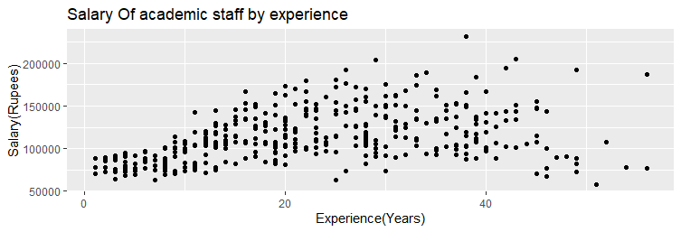

# Ploting Experience VS. Salary (Color represents)

ggplot(Book5)+geom_point(aes(`Years since PhD

+ degree`,Salary,color=Rank))+labs(title = "Salary of Academic staff by rank and Experience",x="Experience(Years)",y="Salary")

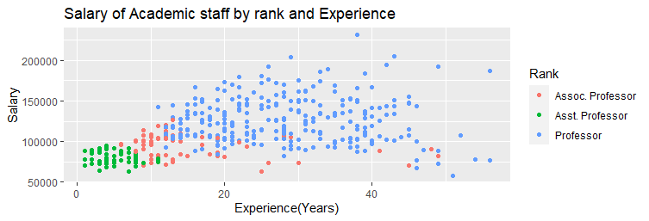

## *Ploting Experience vs Salary(color represents rank,shape represents sex)

ggplot(Book5)+geom_point(aes(`Years since PhD

+ degree`,Salary,color=Rank,shape=Sex,size=2,alpha=.5))+labs(title = "Salary of Academic staff by rank and Experience",x="Experience(Years)",y="Salary")

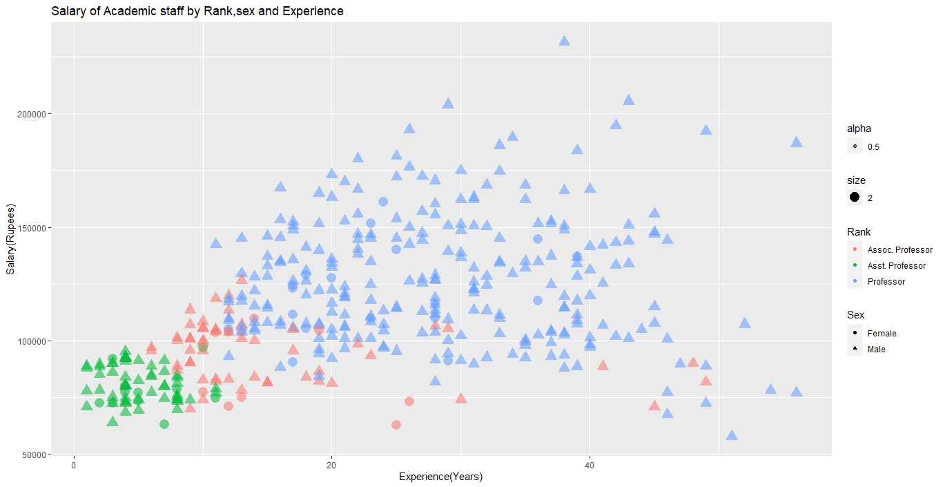

# Bubble Plot

ggplot(Book5)+geom_point(aes(`Years since PhD

+ degree`,Salary,color=Rank,size=`Years of

+ Service`,alpha=.5))+labs(title = "Salary of Academic staff by Rank,sex and Experience",x="Experience(Years)",y="Salary(Rupees)")

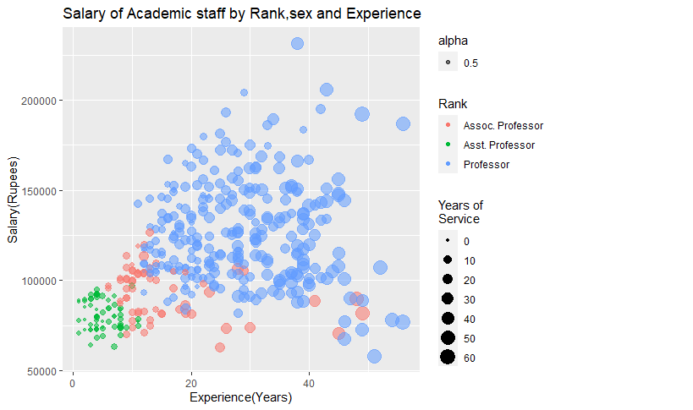

# Faceting Method:-

Grouping method allows to plot multiple variable in a single graph ,using visual characteristics such a color,shape and size.Grouping facilitates to plot the data for multiple groups in a single graph. But in Faceting method :-

Faceting is the process that split the chart window in several small parts (a grid), and display a similar chart in each section. Faceting generates small multiples\Plot each showing a different subset of the data.

#plot salary histogram by rank

>ggplot(Book5)+geom_histogram(aes(x=Salary),fill="grey",color="red",bins=30)+facet_wrap(~Rank,ncol=1)+labs(title ="Salary histogram of academic staff by rank",x="Salary(Rupees)")

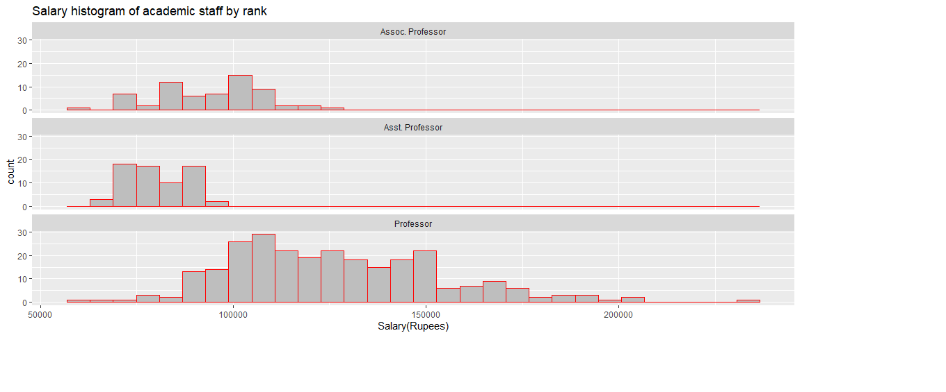

## Two variable are used to define Facets

#facet_grid():-facet_grid() forms a matrix of panels defined by row and column faceting variables.

It is most useful when you have two discrete variables, and all combinations of the variables exist in the data. If you have only one variable with many levels, try [facet_wrap()](http://127.0.0.1:39069/help/library/ggplot2/help/facet_wrap). facet_grid(row variable (s) ~ coloumn variable (s) )

>ggplot(Book5)+geom_histogram(aes(Salary),fill="grey",color="red",bins = 30)+facet_grid(Sex~Rank)+labs(title = "Salary Histogram of academic staff by Sex andRank",x="Salary(Rupees)”)

